Output

Graphs:-

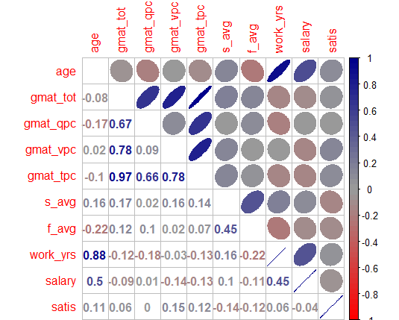

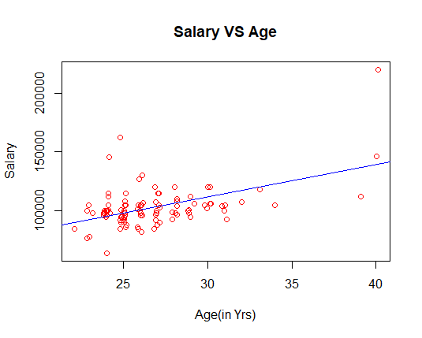

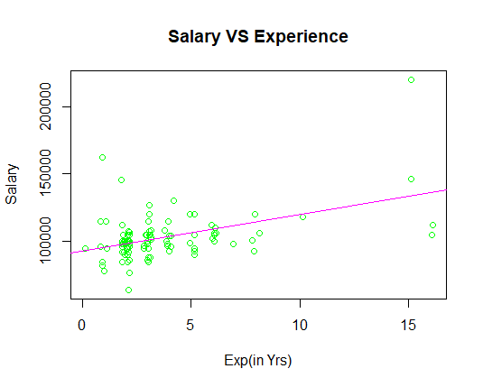

Regression Models:-

Model 1 :-

salary = 29962.6 + 2728.8*(age)

Model 2 :-

salary = 93101 + 2699*(work_yrs)

Model 1 > Model 2 (high R-squared value)